**How to use GitHub on Windows**

1. Create a GitHub account on <https://github.com/>
2. Create a new repository on GitHub

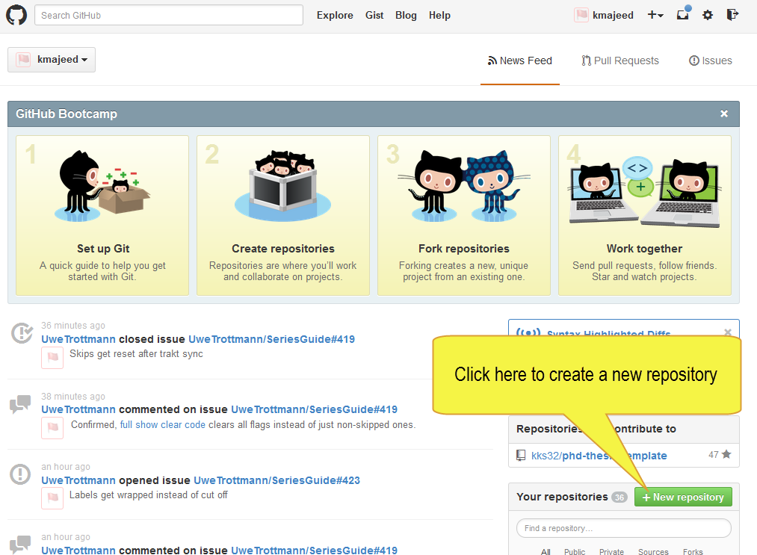

1. Enter the repository details in the next webpage

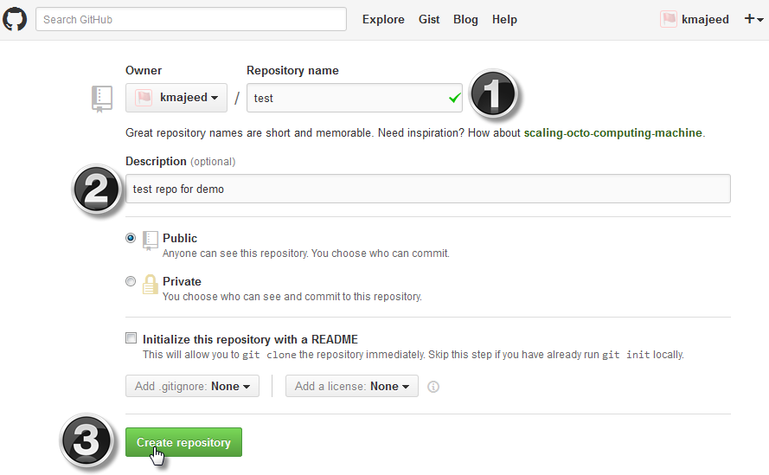

1. Download and install the Github for Windows <http://github-windows.s3.amazonaws.com/GitHubSetup.exe>

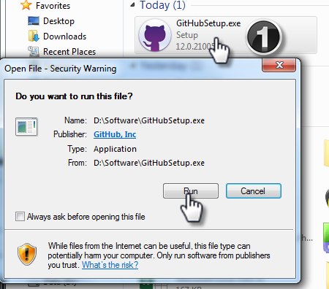 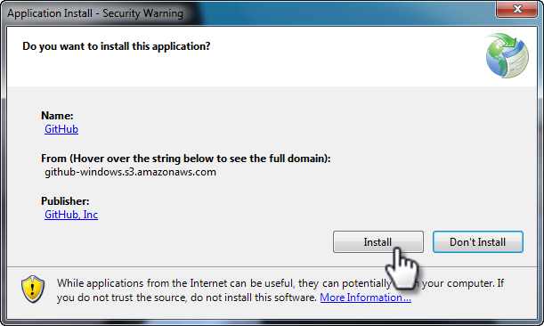

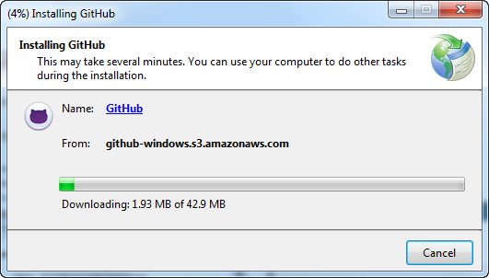

1. Enter you login details for GitHub

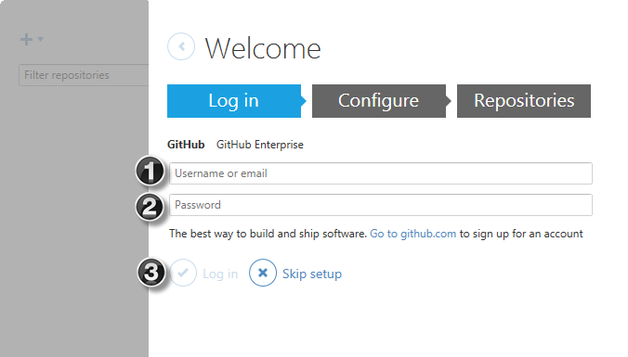 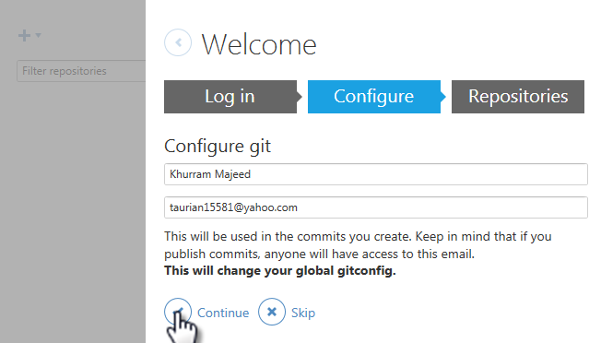

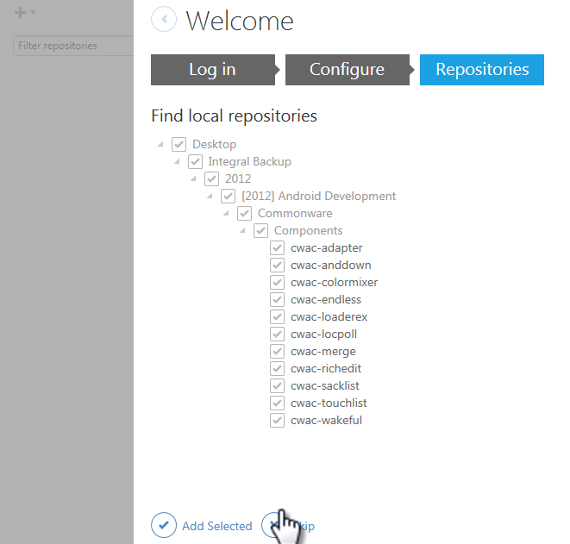

1. Go to Options and update what you want to change

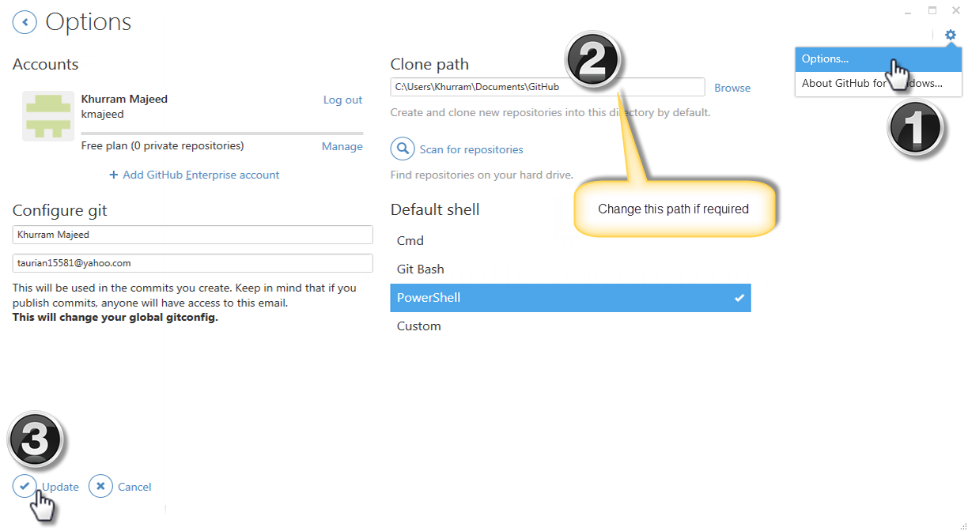

1. Clone the repository you created (in step 2) from GitHub

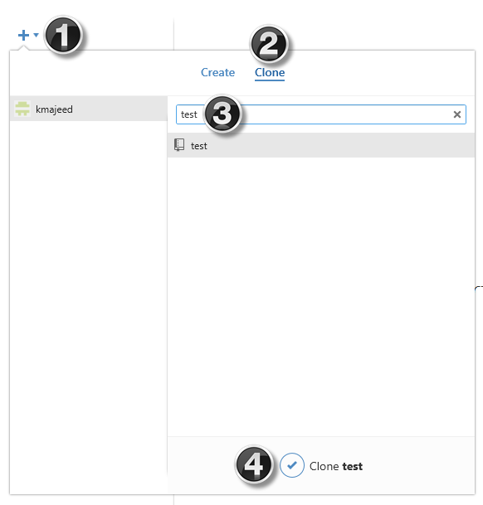 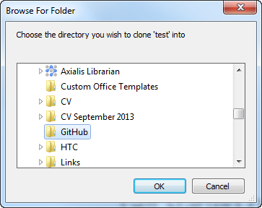

1. As it is new repository it will be empty. Browse to the location of the repository and add your files to the repository

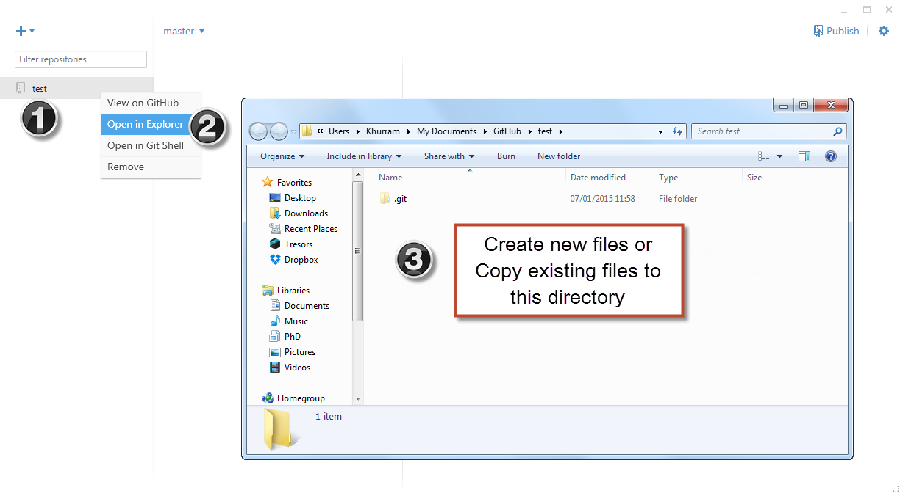

1. Every time you make a change to existing files in repository or add new files, you need to commit the changes and push them to GitHub

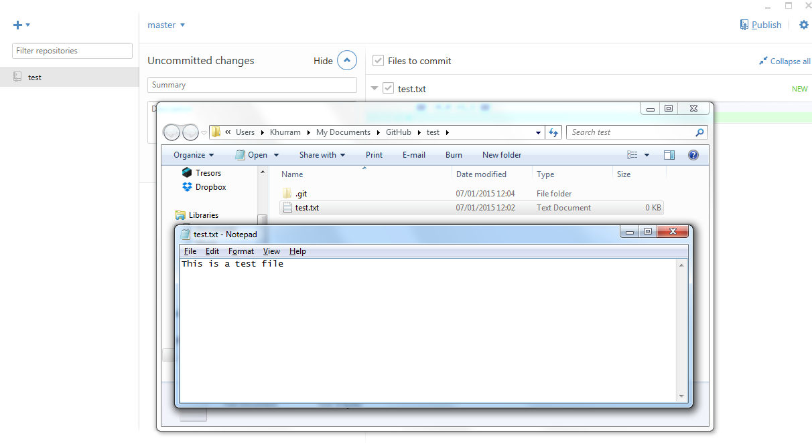

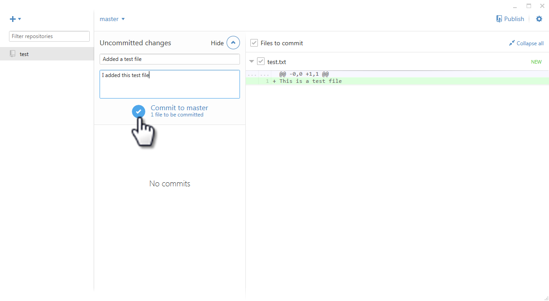

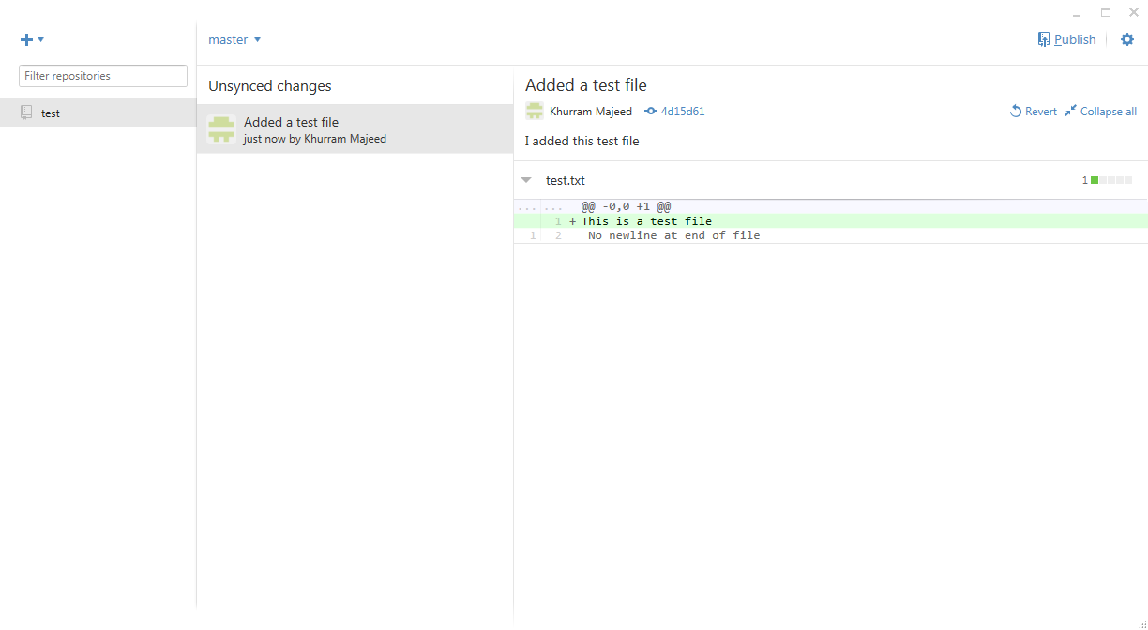

1. Click on publish to push these commits to GitHub server

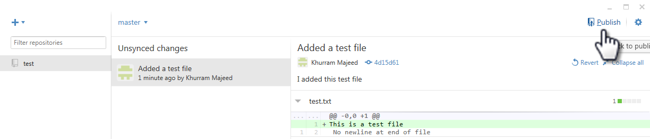

1. Go back to Github.com and you can view your commits

